OC - Fall 2018 (IIIT Sri City)

Practice Assignment 2

1. Use the “man” command to get help for the “ls” command. What command did you type?

~$ man ls

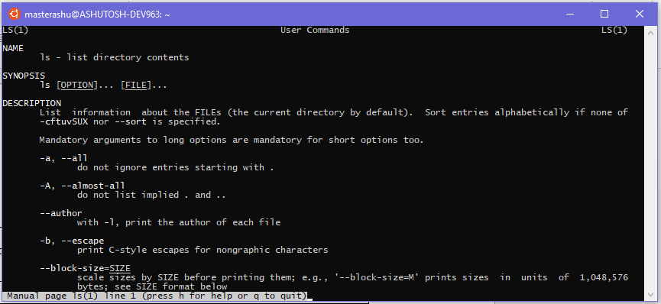

1. Execute the following command: **ls > output.1**

What are the contents of "output.1"?

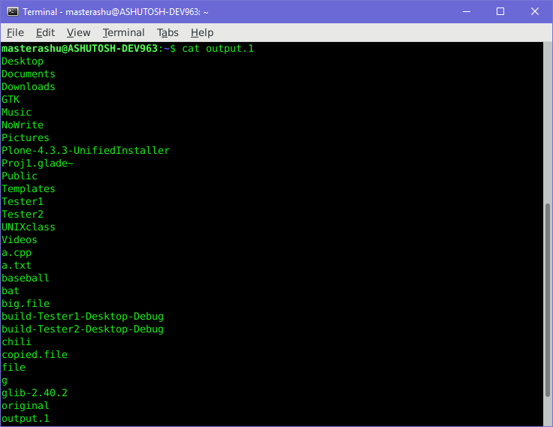

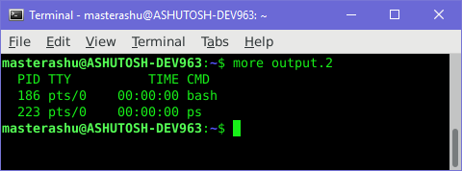

1. Execute the following commands:

**ls > output.2**

**who > output.2**

**ps > output.2**

Use more to check the contents of "output.2".

1. 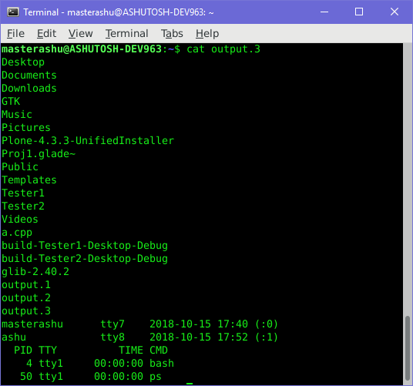Execute the following commands:

**ls > output.3**

**who >> output.3**

**ps >> output.3**

What is the contents of output.3? The output of all three commands.

YES.

1. What “ls” option displays the size of files in **blocks** (other than the -l option, for long listing)?

~$ ls -s

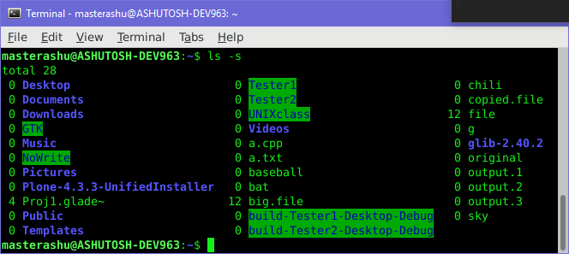

1. What command would you use to make a copy of a file (whose name is **original**) with the name of the copy to be **copied.file** ?

~$ cp original copied.file

1. 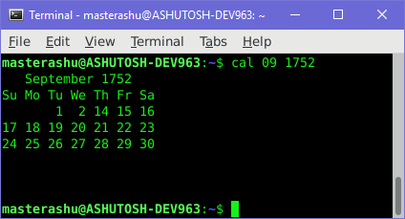Issue the UNIX command **cal 09 1752** What happens?

#it show the calendar for (09 = September) and year 1752

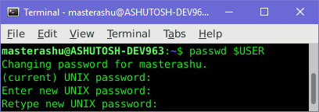

1. What do you do to change your login password?

~$ passwd $USER

1. Find commands that show who is logged onto the system you are on. What commands will do this?

~$ who

1. 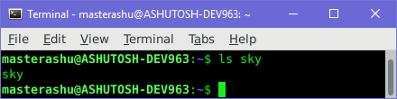The touch command can be used to create new, empty files. Use the following command to create a file named sky: **touch sky**

What command will show you if you succeeded and the file sky now exists?

~$ ls sky

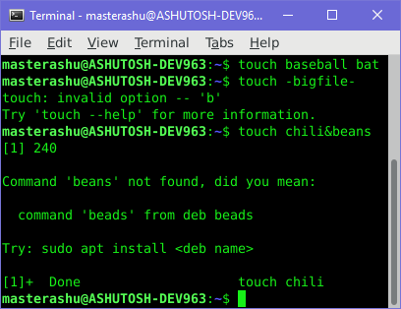

1. Attempt to create three empty files with the commands:

**touch baseball bat touch -bigfile-**

**touch chili&beans**

What error messages occur and are any files created?

1. Create three new directories in the UNIXclass directory; "Letters", "Programs", and "Misc", if they do not already exist.

~$ mkdir UNIXclass

~$ mkdir UNIXclass/Letters UNIXclass/Programs UNIXclass/Misc

1. 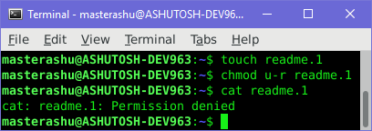Create a file readme.1 and remove its read permission for the user. Try to run cat readme.1

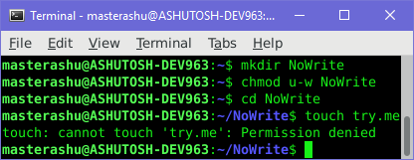

1. a) Create a directory NoWrite and remove its write permission for the user. cd into the NoWrite directory. Create a new file, named try.me, using the command touch try.me

Observe the output.

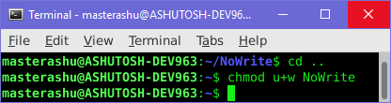

b) Use [cd](http://www.nbcs.rutgers.edu/%7Eedseries/UNIXcmds.html#cd) to go back up one level. What is one command that will change the permissions on the NoWrite directory to allow the creation of files.

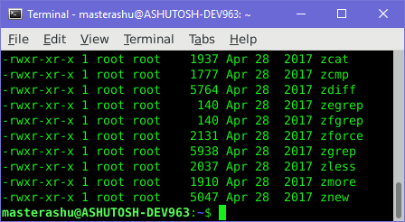

1. ls –l /bin > big.file
   1. Issue the following command:

**cat big.file**

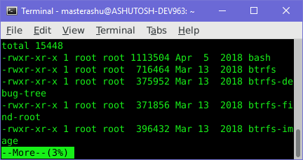

* 1. Now issue the following command:

**more big.file**

* 1. Observe the difference between the commands "cat" and "more"?

“cat” shows the whole content at once, while “more” allows us to see the content line by line pressing <ENTER> key

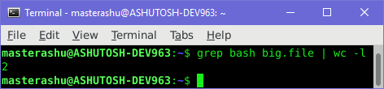

* 1. How many lines in big.file contain the character string "bash"? What command did you use?

1. 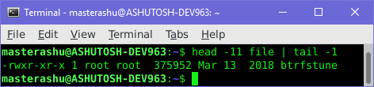Use the head and tail command to read the 11th line of a file.
2. 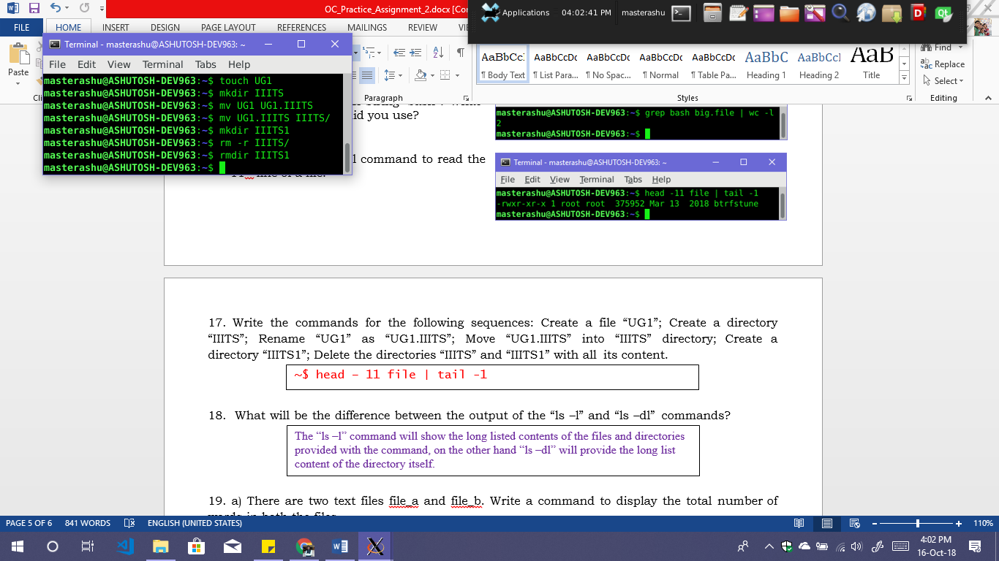Write the commands for the following sequences: Create a file “UG1”; Create a directory “IIITS”; Rename “UG1” as “UG1.IIITS”; Move “UG1.IIITS” into “IIITS” directory; Create a directory “IIITS1”; Delete the directories “IIITS” and “IIITS1” with all its content.

1. What will be the difference between the output of the “ls –l” and “ls –dl” commands?

The “ls –l” command will show the long listed contents of the files and directories provided with the command, on the other hand “ls –dl” will provide the long list content of the directory itself.

1. a) There are two text files file_a and file_b. Write a command to display the total number of words in both the files.

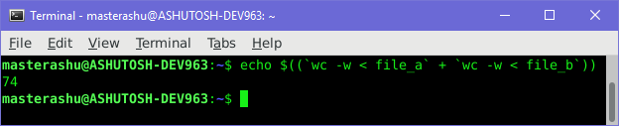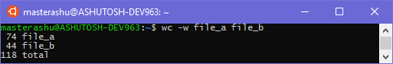

~$ echo $((`wc -w < file_a` + `wc -w < file_b`))

~$ wc –w file_a file_b

b) Write a command to display the list of directories to be searched in your system to execute a command.

~$ echo $PATH

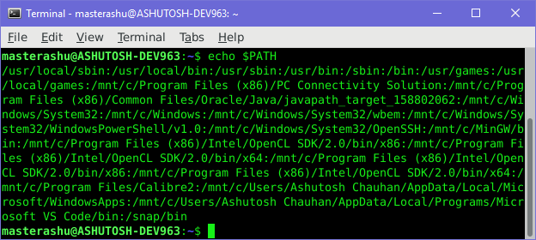

1. **"Hands-on" Questions:** Tasks:
   1. 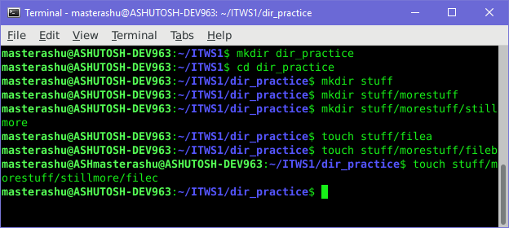Change to your **ITWS1** directory (if you haven't created a ITWS1 directory, create one in your home directory using the command **mkdir ITWS1**). Create a directory to be contained in your **ITWS1** directory called **dir_practice**. Change to the **dir_practice** directory.
   2. Create the following directories in your current directory: stuff

stuff/morestuff stuff/morestuff/stillmore

* 1. Create 3 empty files (filea, fileb, filec) in the following directories as shown below. Issue these commands without changing directories first. stuff/filea

stuff/morestuff/fileb stuff/morestuff/stillmore/filec

Challenge: can you issue a single unix command to accomplish all three tasks?



* 1. From your home directory, enter "ls -R". What information does this give you? 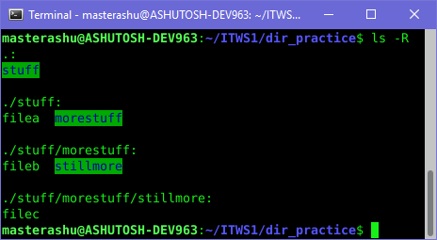
  2. Create a file called **stuff/mystuff** using the cat command. This file should contain the following contents:

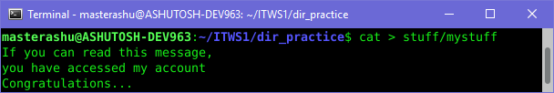If you can read this message, you have accessed my account Congratulations...

* 1. Rename the file "stuff/filea" to be called "stuff/filex". Rename the file "stuff/morestuff/fileb" to be called "stuff/morestuff/stillmore/filec" but issue a command to prompt you if that file already exists. If the file called "stuff/morestuff/stillmore/filec" already exists, answer "n" to the prompt. 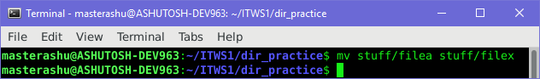

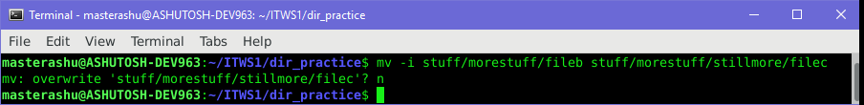

* 1. Make a copy of the file "stuff/filex" to be called "filex.bak" to be contained in your home directory.

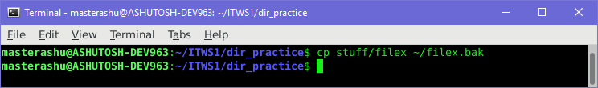

* 1. Delete your **stuff** directory and everything that it contains. Be sure to have the system prompt you to delete each subdirectory and it's contents. Answer "y" to the prompts.

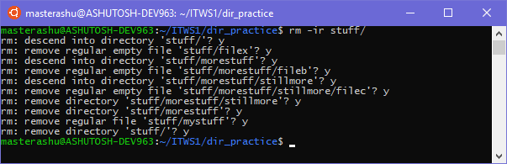

1. **//** Question from class.

Make a folder and check the result after removing read, write and execute permissions.

